OOSE Practical List
1. 1. To develop a problem statement.
Allocation of project definition and analysis. Allocation of project title.
- Define problem statement and Write a project abstract (Short description of project minimum 150 words).
2. 2. Develop an IEEE standard SRS document.
Prepare SRS for given system with given template (Theory)
- Introduction
  - Purpose
  - Scope
  - References
- Overall Project Description
- Problem Statement
- Proposed Solution
- Objective of the Project
- Scope of the Project
- Functional Requirements
  - Software Requirements
  - Hardware Requirements
  - Database Requirements
- Non-Functional Requirement
  - Performance Requirements
  - Security Requirements
  - Safety Requirements
  - Scalability Requirements
3. Prepare UML diagrams.
1. Identify Use Cases and develop the Use Case model.
2. Identify the business activities and develop an UML Activity diagram.
3. Identity the conceptual classes and develop a domain model with UML Class diagram.
4. Draw the Sequence diagram.
5. Draw the State Chart diagram.
6. Draw Component .
7. Draw Deployment diagrams.

9. Write a Program to implement Factory pattern. Use below class diagram.
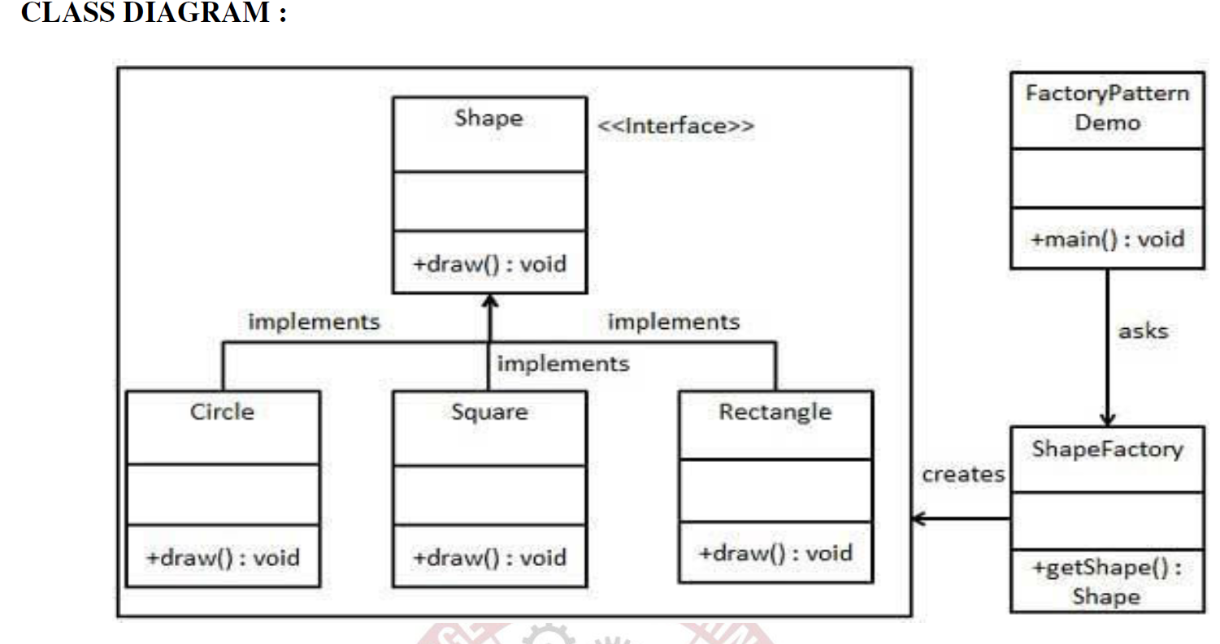

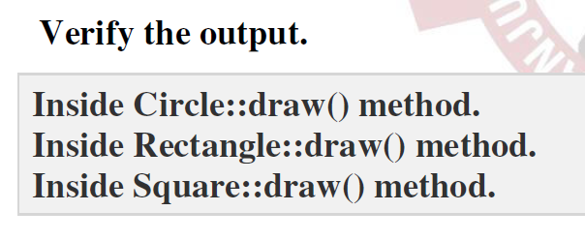

5. Write a program to implement singleton pattern.Use below class diagram for reference.
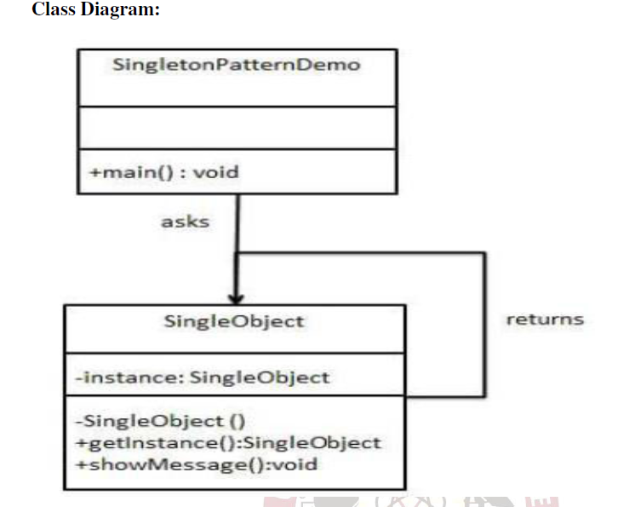

Suggested domains for Mini-project.
1. Passport automation system.
2. Library Management
3. Exam registration
4. Stock maintenance system.
5. Online course learning system
6. Airline/Railway reservation system
7. Software personnel management system
8. E-commerce
9. e-book management system
10. Recruitment system
11. Banking System
12. Conference management system
13. Attendance management system
14. Restaurant management system
15. Student Information system
16. Admission system
17.Ai chat board
18. Inventory management system
19. Hospital management
20. Grocery management
21.Fitness (gym) system
22.School management system
23.OLX
24.Quiz app
25.Spotify (music app)
26.home service(plumber,electrician erc)
27.Online property management
28.Travelling app
29.

Suggested SoftwareTools
Star UML, Eclipse IDE, Visual Paradigm

